**M.C.E. Society's**

**Allana Institute of Management**

**Sciences**



**Synopsis On**

**“Blogging Website”**

**Submitted To**

**Savitribai Phule Pune University**

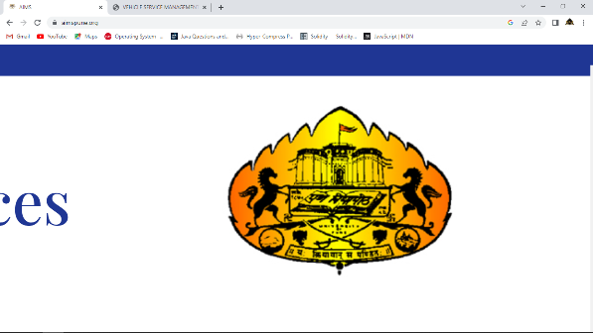

**In partial fulfilment of requirement for the award of degree**

**MCA**

**Submitted By**

**Ladaf Bilal Ajimoddin**

**Under the Guidance of**

**Prof. Mehdi Ali Jafri**

**For Academic Year**

**2022-23”**

**DECLARATION**

I hereby declare that the mini project work entitled “**BloggingWebsite**” submitted to the Savitribai Phule Pune University, Pune, is a record of an original work done by me under the guidance of

**Prof**. **Mehdi Ali Jafri**

Date : Signature of the

Candidate

Sign:

**Prof. Mehdi Ali Jafri**

**CERTIFICATE**

This is to certify that **Mr. Ladaf Bilal Ajimoddin** Roll No: **37** has successfully completed his project titled “**Blogging Website**”. The same constitutes a part of MCA Semester III curriculum for the Academic Year 2022- 2023. Submitted in Partial Fulfilment of the requirement for Mini Project recognized by University of Pune.

University Seat No

Ms. Tabassum Shaikh Dr. Roshan Kazi

**MCA Co-Ordinator** **Director**

**External Examiner Sign Of Examiners :**

1. _______________ ________________
2. _______________ ________________

**Date Of Examination:**

**ACKNOWLEDGEMENT**

I take pleasure in presenting my project work. I am thankful to my project guide Prof. **Mehdi Ali Jafri** of the college project guide of AIMS, who keeps monitoring my project continuously to complete it in time as per the expectations of the course.

“Ability is of little account without opportunity”, I wish to thank our Director **Dr. Roshan Kazi** sir, who gave me a very bright learning opportunity, during my course to prove my ability and skills.

I would also like to thank **Ms. Tabassum Shaikh** (MCA Co-Ordinator) for providing all the necessary facilities at college during the development of this project.

Last but not least I would like to express my heartfelt gratitude towards staff members of AIMS, my colleagues and friends for their moral and technical support throughout the duration of the project.

My Sincere Thanks to all

**Ladaf Bilal**

**INDEX**

|  |  |  |
| --- | --- | --- |
| **SR. NO.** | **TOPICS** | **PAGE NO** |
| CHAPTER 1 | **INTRODUCTION AND SYNOPSIS** |  |
| **1.1** | INTRODUCTION OF PROJECT |  |
| 1.2 | EXISTING SYSTEM AND NEED FOR SYSTEM |  |
| 1.3 | SCOPE OF WORK |  |
| 1.4 | OPERATING ENVIRONMENT- HARDWARE AND SOFTWARE |  |
| CHAPTER 2 | **SOFTWARE REQUIREMENT SPECIFICATION AND PROPOSED SYSTEM** |  |
| 2.1 | PROPOSED SYSTEM |  |
| 2.2 | SRS |  |
| **CHAPTER 3** | **ANALYSIS & DESIGN** |  |
| 3.1 | CLASS DIAGRAM / OBJECT DIAGRAM |  |
| 3.2 | USE CASE DIAGRAM |  |
| 3.3 | ACTIVITY DIAGRAM |  |
| 3.4 | COMPONENT DIAGRAM |  |
| 3.5 | SEQUENCE DIAGRAM |  |
| 3.6 | DEPLOYMENT DIAGRAM |  |
| **CHAPTER 4** | **IMPLEMENTATION & DATABASE** |  |
| 4.1 | USER INTERFACE DESIGN (SCREEN - INPUT FORMS WITH DATA) |  |
| 4.2 | OUTPUT REPORTS WITH DATA |  |
| 4.3 | DATABASE STRUCTURES - DATA DICTIONARY |  |
| 4.4 | CODE SNIPPET |  |
| CHAPTER 5 | DRAWBACKS AND LIMITATION |  |
| CHAPTER 6 | PROPOSED EHANCEMENT |  |
| CHAPTER 7 | CONCLUSION |  |
| CHAPTER 8 | BIBILIOGRAPHY |  |

1. **INTRODUCTION**

**AND**

**SYNOPSIS**

* 1. **INTRODUCTION OF PROJECT**
* The “Online Blogging System” has been developed to override the problems prevailing in the practicing manual system.
* This software is supported to eliminate and in some cases reduce the hardships faced by this existing system.
* Moreover this system is designed for the particular need of the company to carry out operations in a smooth and effective manner.
* The application is reduced as such as possible to avoid errors while entering the data.
* It also provide error message while entering invalid data. No forma knowledge is needed for the user to use to use this system.
* Thus by this all it proven it is user-friendly. Online Blogging System, as described above, can lead to error free, secure, reliable and fast management system.
* It can assist the user to concentrate on their other activities rather to concentrate on the record keeping.
* Thus it will help organization in better utilization of resources.
  1. **EXISTING SYSTEM AND PROPOSED SYSTEM**
* Every organization, whether big or small, has challenges to overcome and managing the information of Comment, Blogs, New Blog, Comment, Technology Blog.
* Every Online Blogging System has different Blogs needs, therefore we design exclusive employee management systems that are adapted to your managerial requirements.
* This is designed to assist in strategic planning, and will help you ensure that your organization is equipped with the right level of information and details for your future goals.
* Also, for those busy executive who are always on the go, our systems come with remote access features, which will allow you to manage your workforce anytime, at all times. These systems will ultimately allow you to better manage resources.
  1. **SCOPE OF WORK**

It may help collecting perfect management in details. In a very short time, the collection will be obvious, simple and sensible. It will help a person to know the management of passed year perfectly and vividly. It also helps in current all works relative to Online Blogging System. It will be also reduced the cost of collecting the management & collection procedure will go on smoothly.

Our project aims at Business process automation, i.e. we have tried to computerize various processes of Online Blogging System.

* In computer system the person has to fill the various forms & number of copies of the forms can be easily generated at a time.
* In computer system, it is not necessary to create the manifest but we can directly print it, which saves our time
* To assist the staff in capturing the effort spent on their respective working areas.
* To utilize resources in an efficient manner by increasing their productivity through automation.
* The system generates types of information that can be used for various purposes.
* It satisfy the user requirement
* Be easy to understand by the user and operator
* Be easy to operate
* Have a good user interface
* Delivered on schedule within the budget.
  1. **OPERATING ENVIRONMENT HARDWARE AND SOFTWARE**

**Technology Used:**

* **PhpMyAdmin**
* **Php, HTML, CSS, JavaScript**

 

 

**HARDWARE SPECIFICATION:**

**\*HARDWARE:-**

* + Minimum 4 to 8GB RAM
  + Minimum 512 GB HDD
  + Processor intel i5, Ryzen 3,5,7

**\*SOFTWARE:-**

* + Visual Studio Code
  + PhpMyAdmin
  + XAMPP Control Panel

1. **SOFTWARE REQUIREMENT SPECIFICATION**

**AND**

**PROPOSED SYSTEM**

* 1. **PROPOSED SYSTEM**

**Features of the project Online Blogging System**

• Product and Component based

• Creating & Changing Issues at ease

• Query Issue List to any depth

• Reporting & Charting in more comprehensive way

• User Accounts to control the access and maintain security

• Simple Status & Resolutions

• Multi-level Priorities & Severities

• Targets & Milestones for guiding the programmers

• Attachments & Additional Comments for more information

• Robust database back-end

• Various level of reports available with a lot of filter criteria's

• It contain better storage capacity

• Accuracy in work.

• Easy & fast retrieval of information

• Well designed reports

• Decrease the load of the person involve in existing manual system.

• Access of any information individually.

• Work becomes very speedy.

• Easy to update information

* 1. **SRS**

**Software Requirement Specification: (SRS)**

The Software Requirements Specification is produced at the culmination of the analysis task. The function and performance allocated to software as part of system engineering are refined by establishing a complete information description, a detailed functional and behavioral description, an indication of performance requirements and design constraints, appropriate validation criteria, and other data pertinent to requirements.

**The proposed system has the following requirements:**

* System needs store information about new entry of Blogs.
* System needs to help the internal staff to keep information of Comment and find them as per various queries.
* System need to maintain quantity record.
* System need to keep the record of New Category.
* System need to update and delete the record.
* System also needs a search area.
* It also needs a security system to prevent data.

**Identification of need:**

The old manual system was suffering from a series of drawbacks. Since whole of the system was to be maintained with hands the process of keeping, maintaining and retrieving the information was very tedious and lengthy. The records were never used to be in a systematic order. there used to be lots of difficulties in associating any particular transaction with a particular context.

If any information was to be found it was required to go through the different registers, documents there would never exist anything like report generation. There would always be unnecessary consumption of time while entering records and retrieving records. One more problem was that it was very difficult to find errors while entering the records. Once the records were entered it was very difficult to update these records.

The reason behind it is that there is lot of information to be maintained and have to be kept in mind while running the business For this reason we have provided features Present system is partially automated (computerized), actually existing system is quite laborious as one has to enter same information at three different places

**Following points should be well considered:**

* Documents and reports that must be provided by the new system: there can also be few reports, which can help management in decision-making and cost controlling, but since these reports do not get required attention, such kind of reports and information were also identified and given required attention.
* Details of the information needed for each document and report.
* The required frequency and distribution for each document.
* Probable sources of information for each document and report.
* With the implementation of computerized system, the task of keeping records in an organized manner will be solved. The greatest of all is the retrieval of information, which will be at the click of the mouse. So the proposed system helps in saving the time in different operations and making information flow easy giving valuable reports.

**Feasibility Study:**

After doing the project Online Blogging System, study and analyzing all the existing or required functionalities of the system, the next task is to do the feasibility study for the project. All projects are feasible - given unlimited resources and infinite time.

Feasibility study includes consideration of all the possible ways to provide a solution to the given problem. The proposed solution should satisfy all the user requirements and should be flexible enough so that future changes can be easily done based on the future upcoming requirements.

**A. Economical Feasibility**

This is a very important aspect to be considered while developing a project. We decided the technology based on minimum possible cost factor.

* All hardware and software cost has to be borne by the organization.
* Overall we have estimated that the benefits the organization is going to receive from the proposed system will surely overcome the initial costs and the later on running cost for system.

**B. Technical Feasibility**

This included the study of function, performance and constraints that may affect the ability to achieve an acceptable system. For this feasibility study, we studied complete functionality to be provided in the system, as described in the System Requirement Specification (SRS), and checked if everything was possible using different type of frontend and backend plaformst.

**C. Operational Feasibility**

No doubt the proposed system is fully GUI based that is very user friendly and all inputs to be taken all self-explanatory even to a layman. Besides, a proper training has been conducted to let know the essence of the system to the users so that they feel comfortable with new system. As far our study is concerned the clients are comfortable and happy as the system has cut down their loads and doing

**System Design of Online Blogging System**

In this phase, a logical system is built which fulfils the given requirements. Design phase of software development deals with transforming the clients's requirements into a logically working system. Normally, design is performed in the following in the following two steps:

**1. Primary Design Phase:**

In this phase, the system is designed at block level. The blocks are created on the basis of analysis done in the problem identification phase. Different blocks are created for different functions emphasis is put on minimising the information flow between blocks. Thus, all activities which require more interaction are kept in one block.

**2. Secondary Design Phase:**

In the secondary phase the detailed design of every block is performed.

**The general tasks involved in the design process are the following:**

1. Design various blocks for overall system processes.

2. Design smaller, compact and workable modules in each block

3. Design various database structures.

4. Specify details of programs to achieve desired functionality

5. Design the form of inputs, and outputs of the system

6. Perform documentation of the design

7. System reviews.

**Preliminary Product Description:**

The first step in the system development life cycle is the preliminary investigation to determine the feasibility of the system. The purpose of the preliminary investigation is to evaluate project requests. It is not a design study nor does it include the collection of details to describe the business system in all respect. Rather, it is the collecting of information that helps committee members to evaluate the merits of the project request and make an informed judgment about the feasibility of the proposed project.

**Analysts working on the preliminary investigation should accomplish the following objectives:**

* Clarify and understand the project request
* Determine the size of the project.
* Assess costs and benefits of alternative approaches.
* Determine the technical and operational feasibility of alterative approaches.
* Report the findings to management, with recommendations outlining the acceptance or rejection of the proposal.

**Benefit to Organization**

The organization will obviously be able to gain benefits such as savings in operating cost, reduction in paperwork, better utilization of human resources and more presentable image increasing goodwill.

**The Initial Cost**

The initial cost of setting up the system will include the cost of hardware software (OS, add-on software, utilities) & labour (setup & maintenance). The same has to bear by the organization.

**Running Cost**

Besides, the initial cost the long term cost will include the running cost for the system including the AMC, stationary charges, cost for human resources, cost for update/renewal of various related software.

**Need for Training**

The users along with the administrator need to be trained at the time of implementation of the system for smooth running of the system. The client will provide the training site.

We talked to the management people who were managing a the financial issues of the center the staff who were keeping nthe records in lots of registers and the reporting manager regarding their existing system, their requirements and their expectations from the new proposed system. Then, we did the system study of the entire system based on their requirements and the additional features they wanted to incorporate in this system.

1. **ANALYSIS**

**&**

**DESIGN**

**CLASS DIAGRAM**

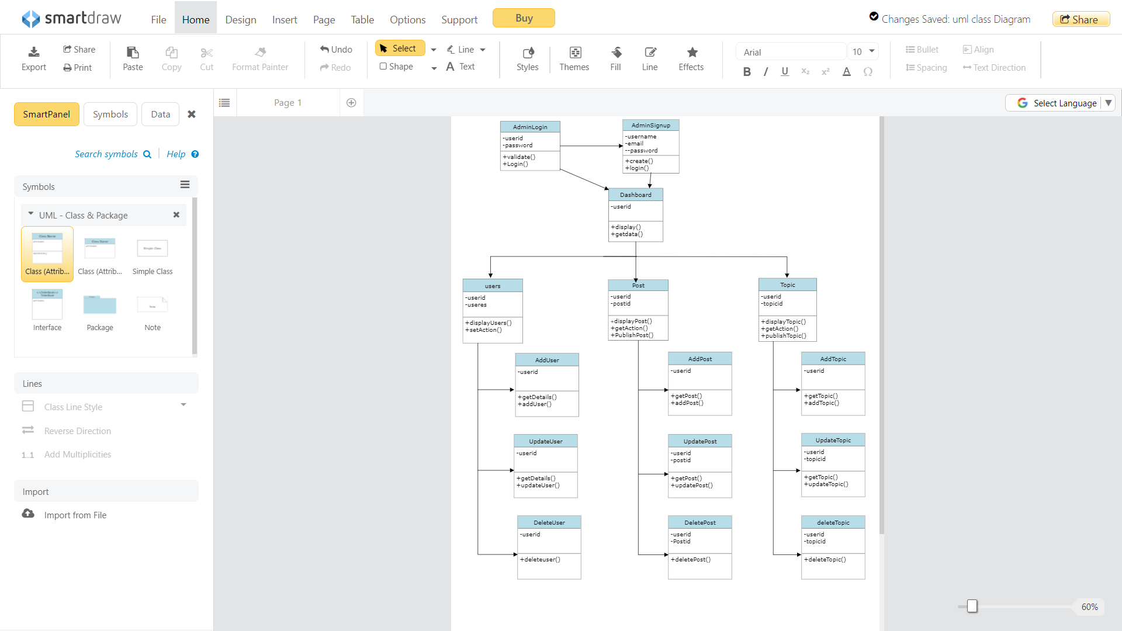

**USE CASE DIAGRAM**

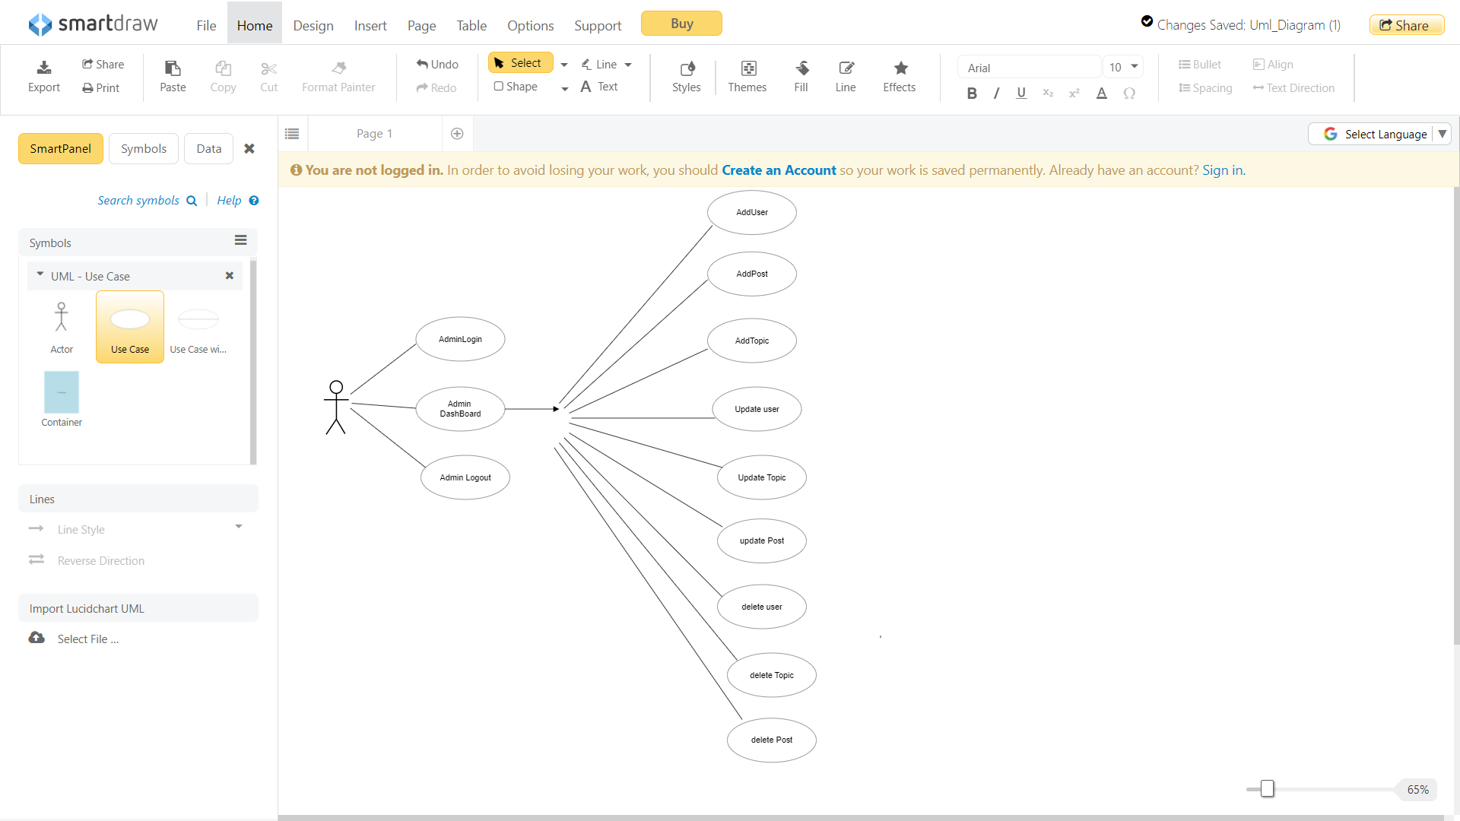

**ACTIVITY DIAGRAM**

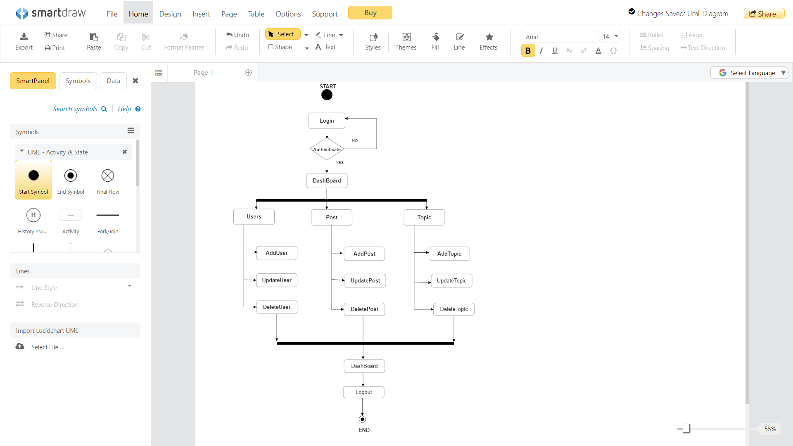

**SEQUENCE DIAGRAM**

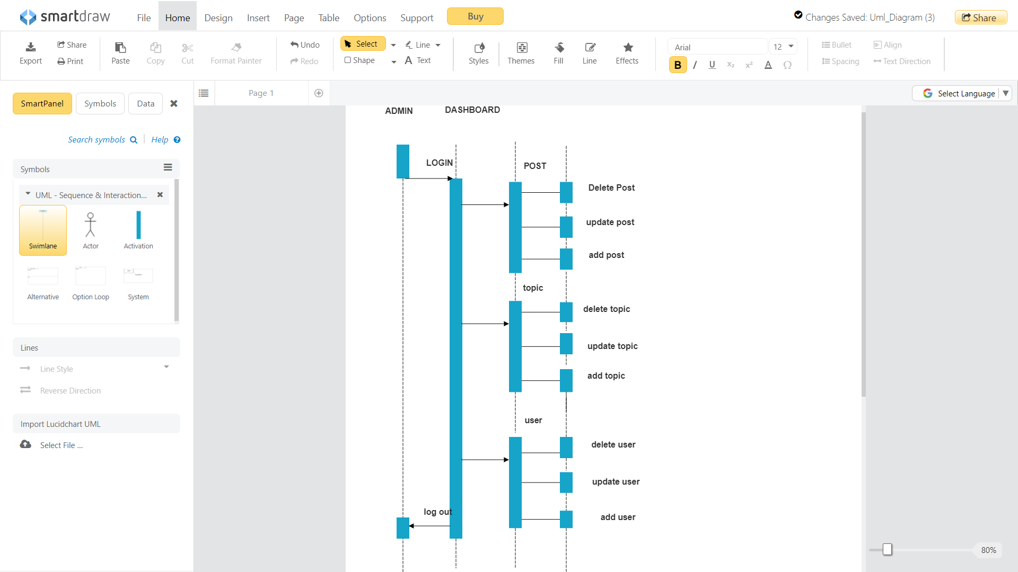

**4. IMPLEMENTATION**

**&**

**DATABASE**

**4.1 User Interface Design (Screen - INPUT FORMS WITH DATA)**

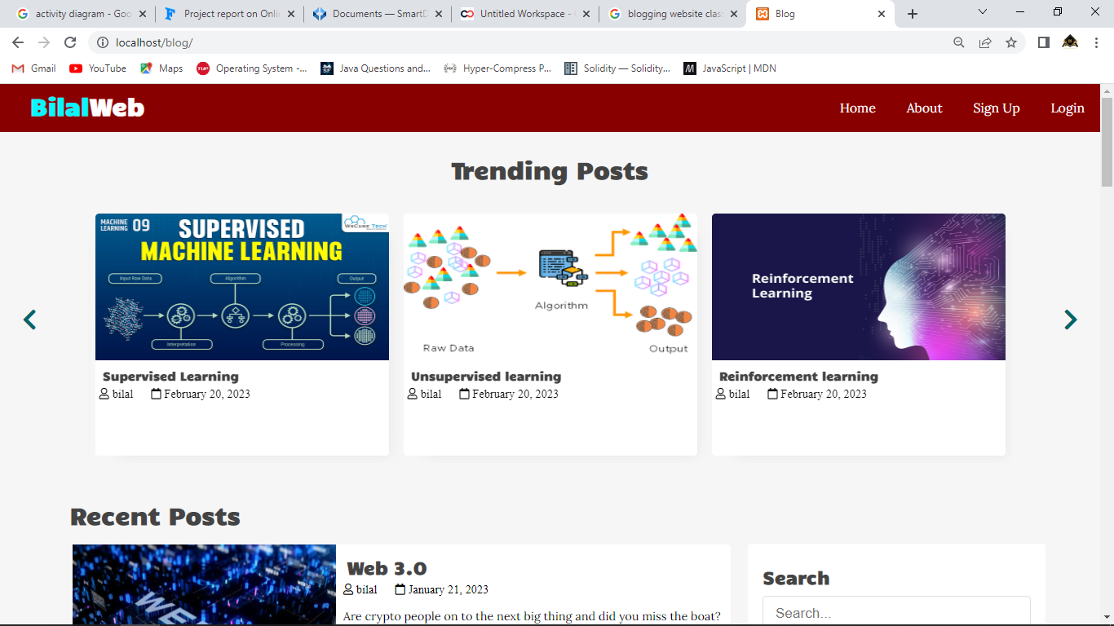

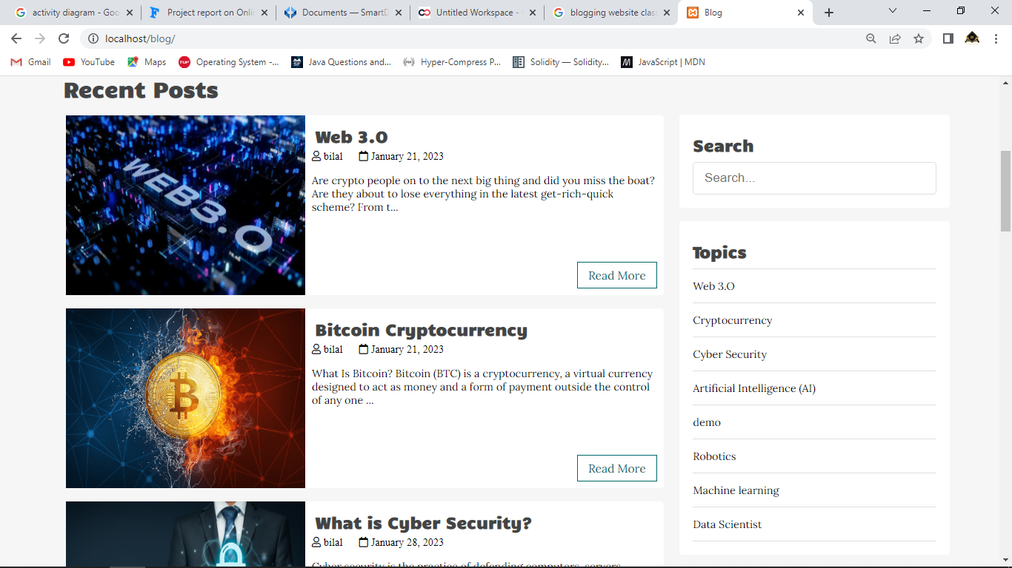

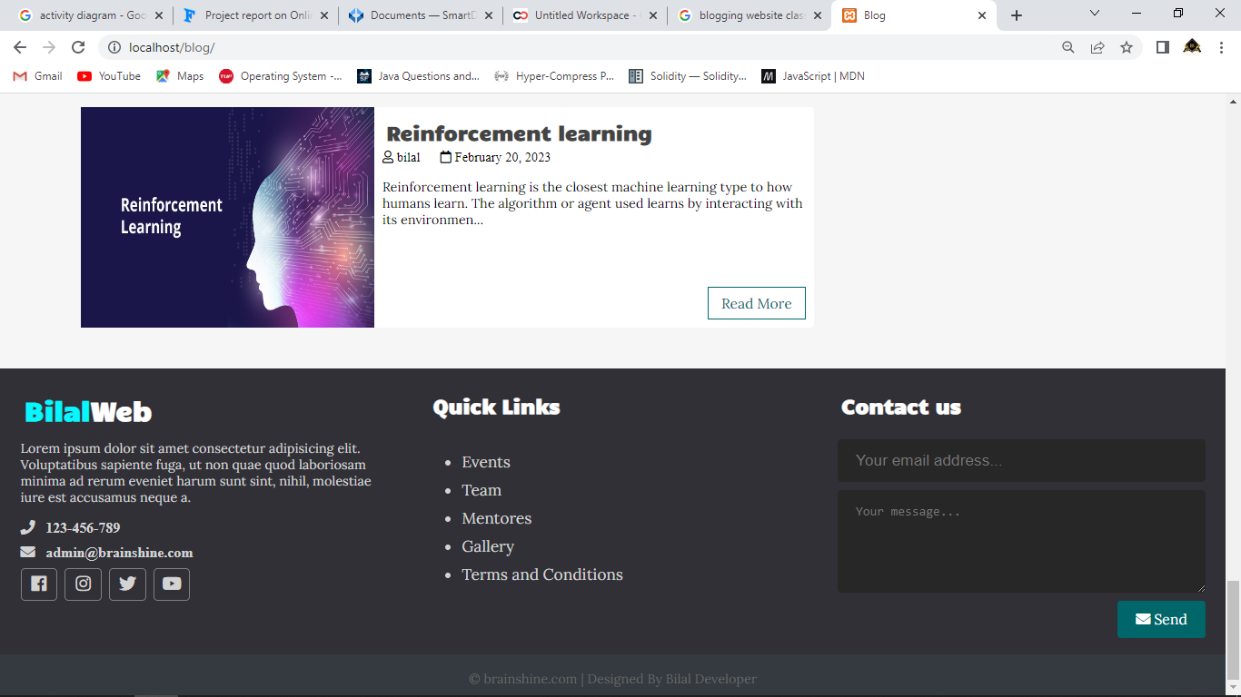

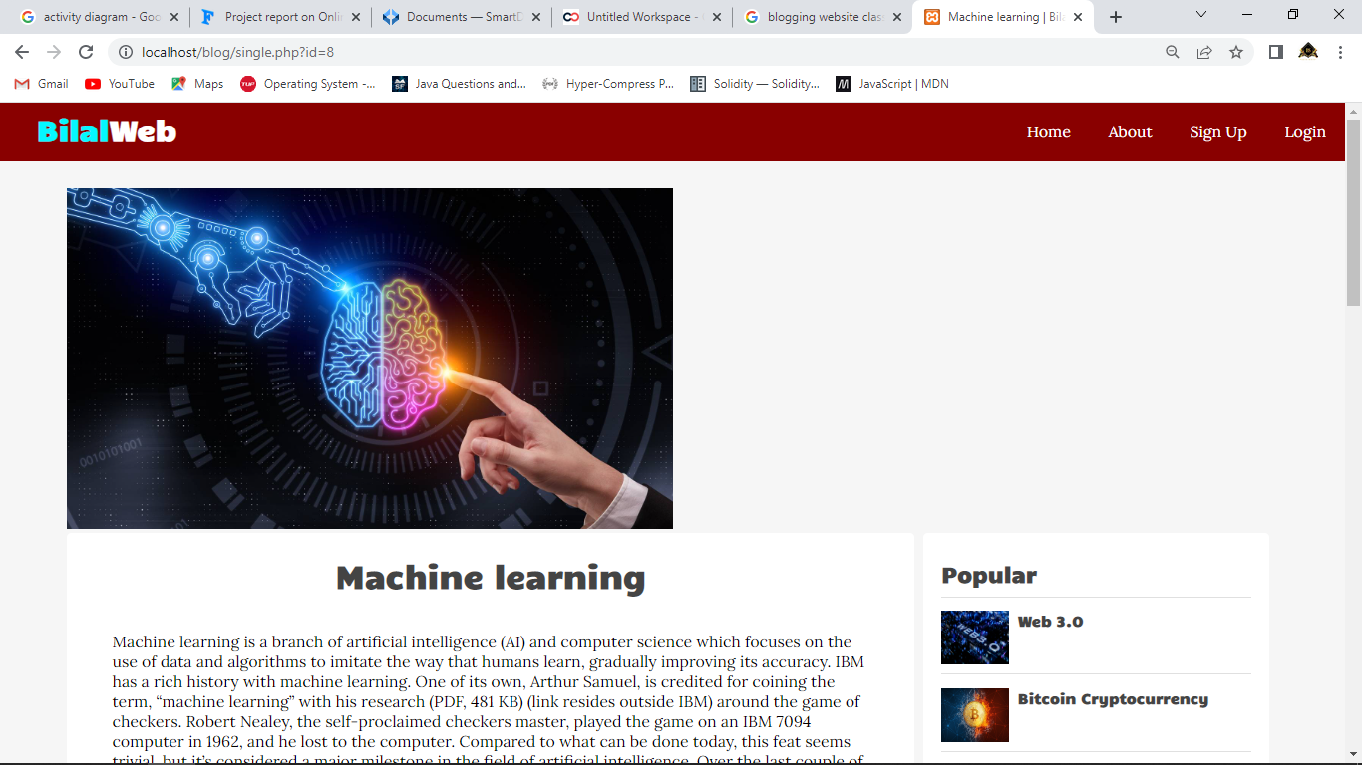

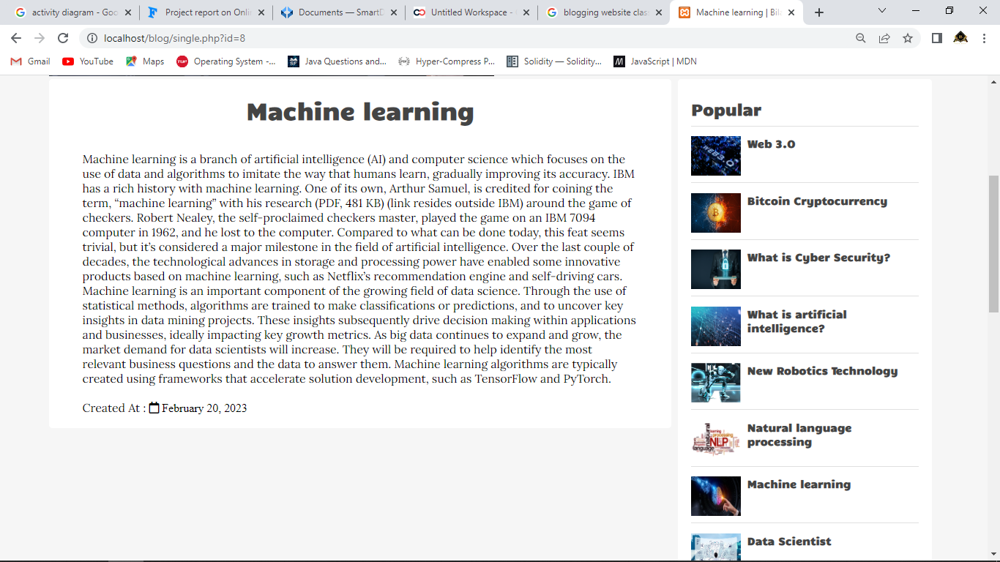

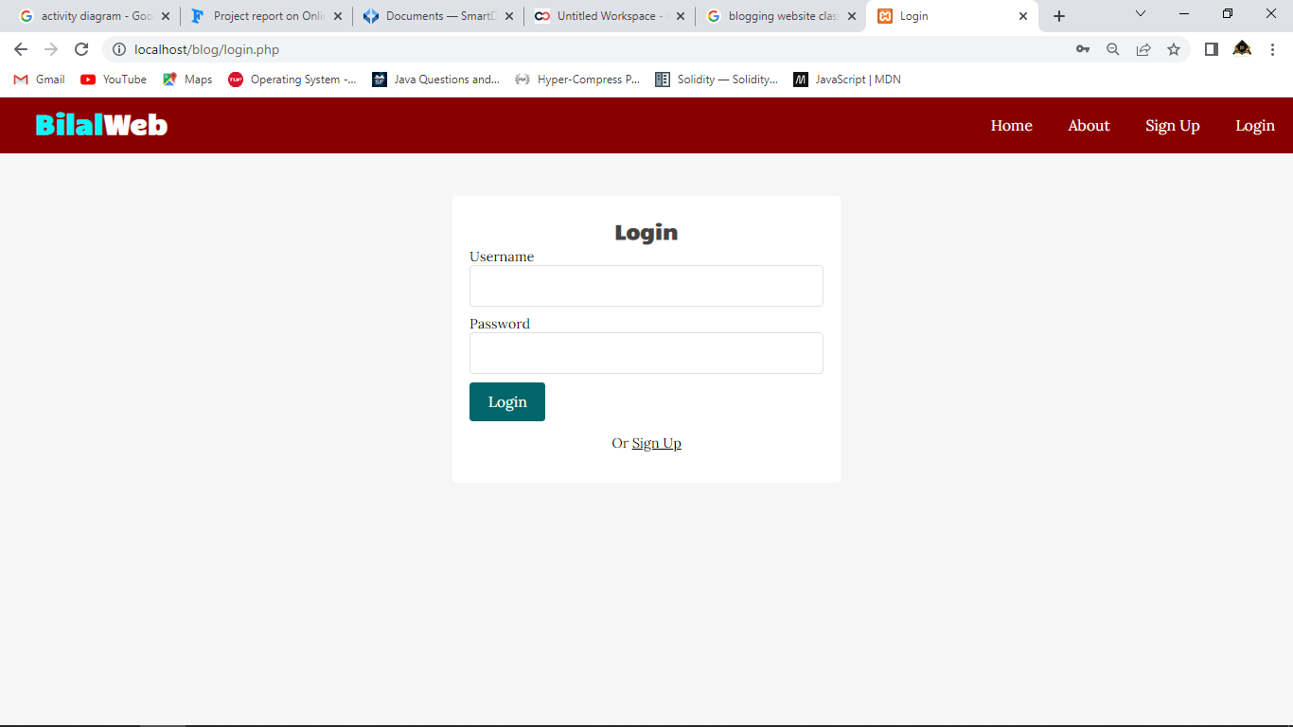

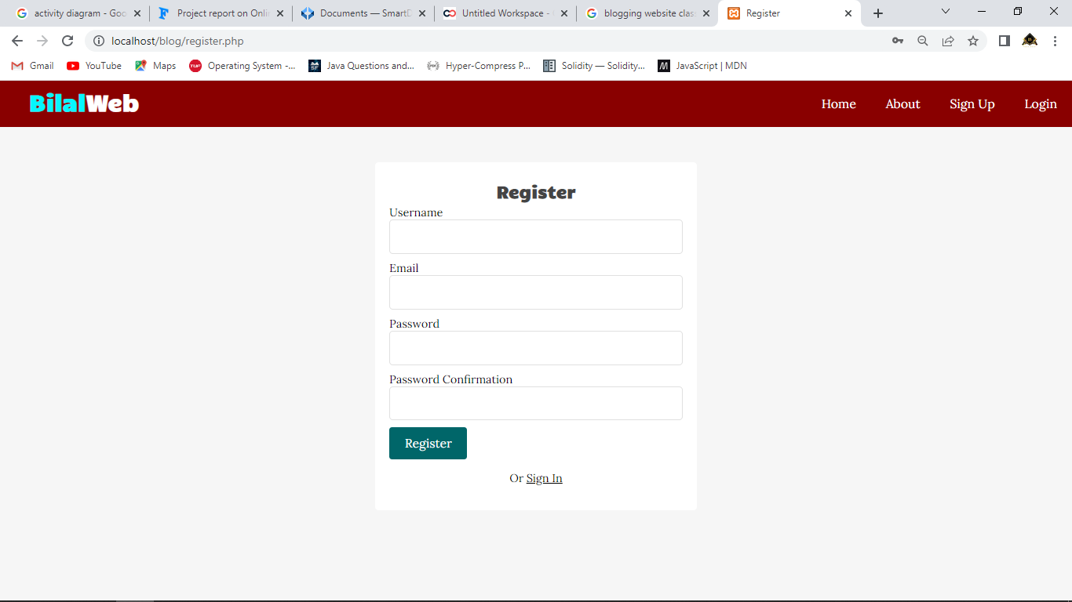

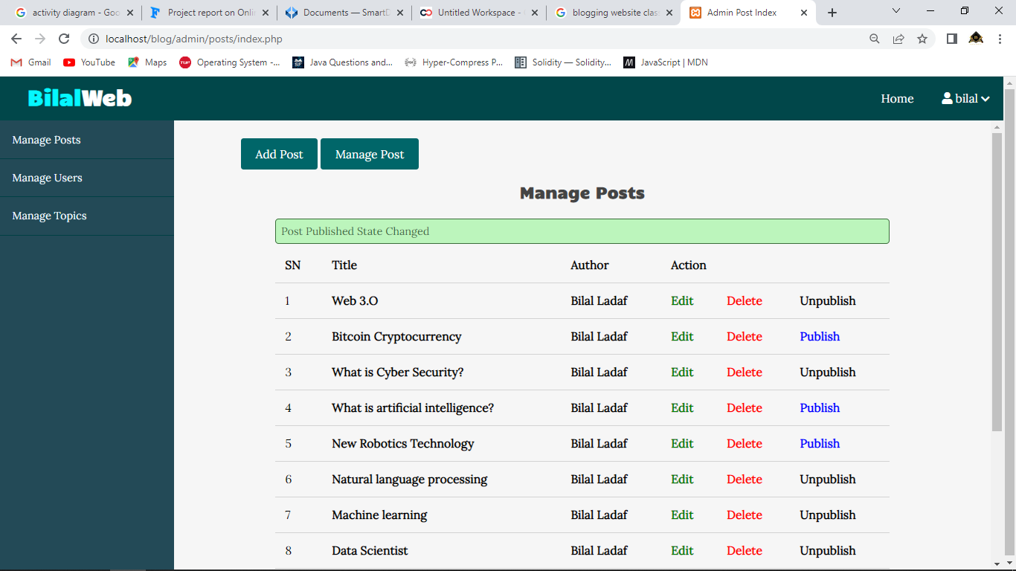

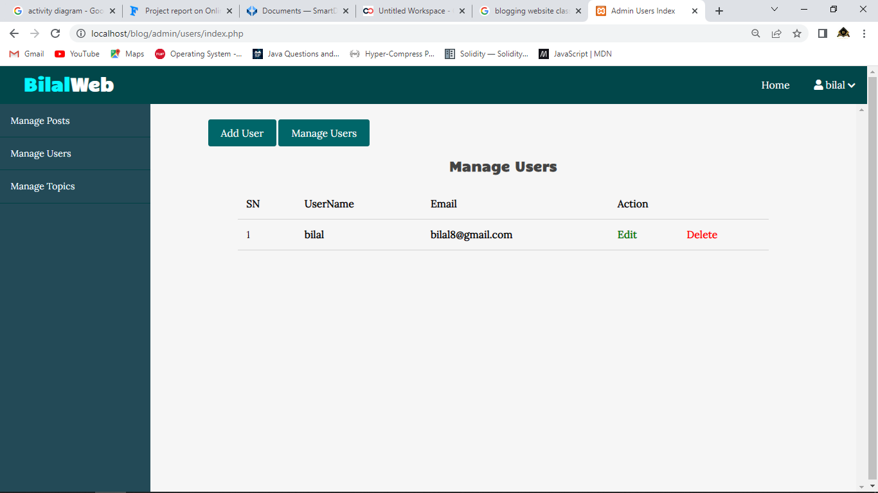

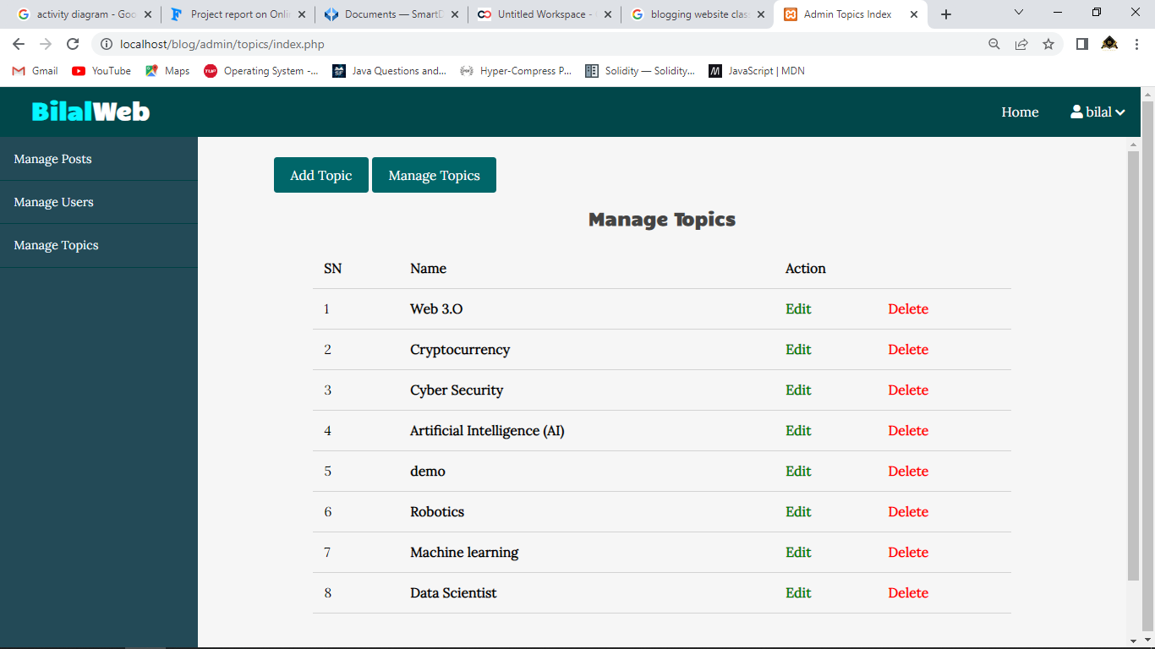

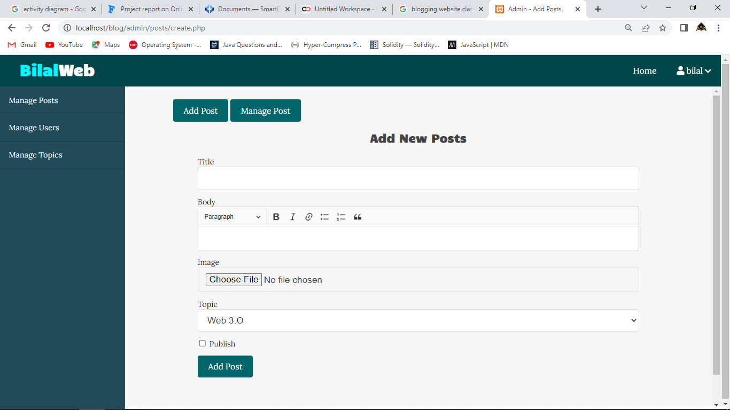

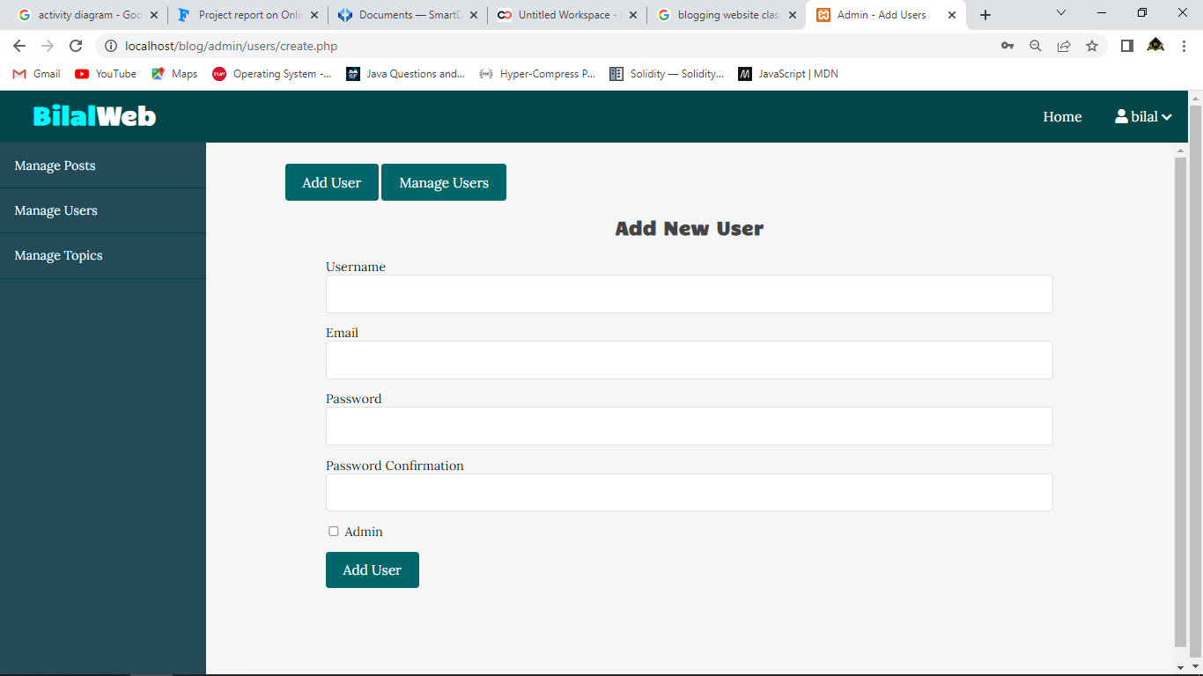

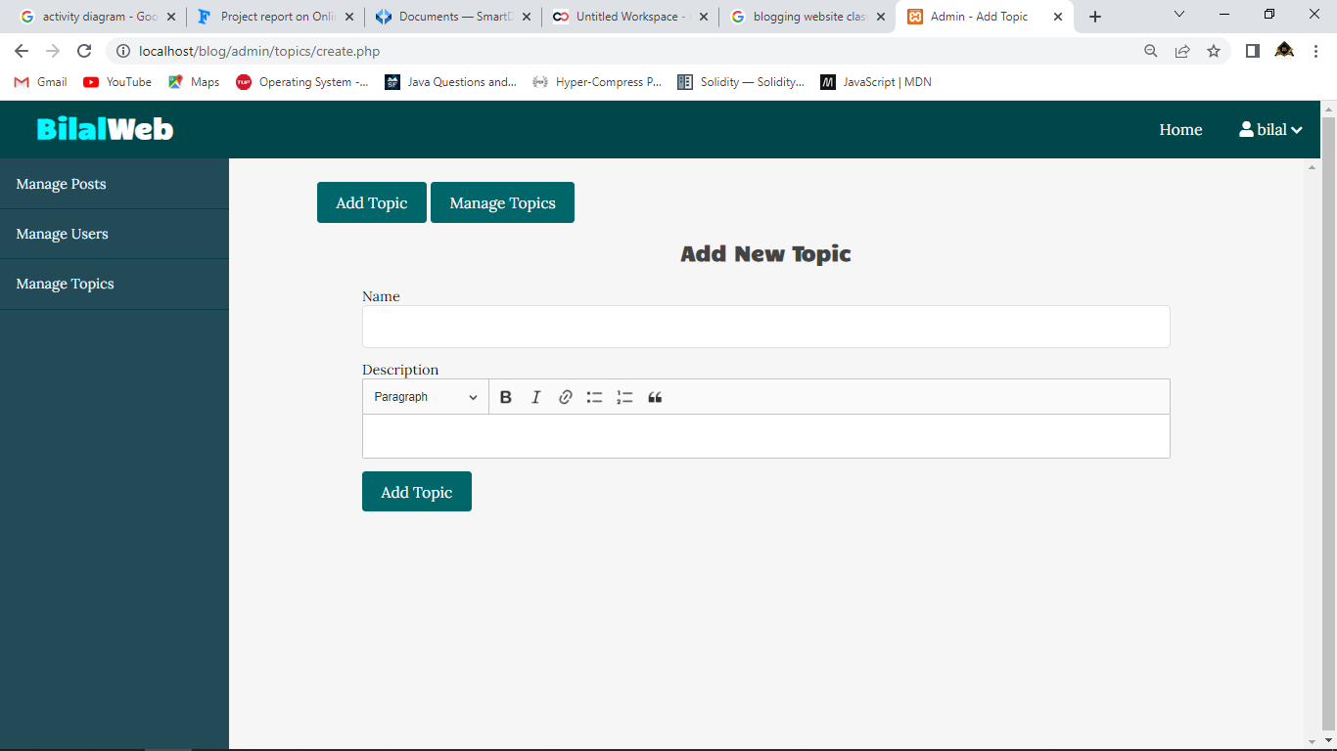

**4.3 Database structures - Data Dictionary**

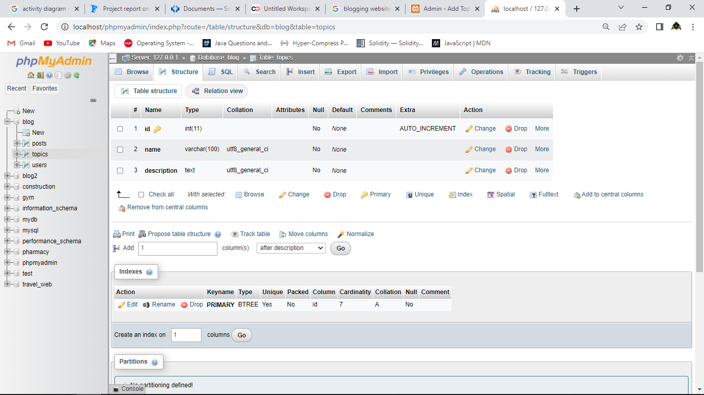

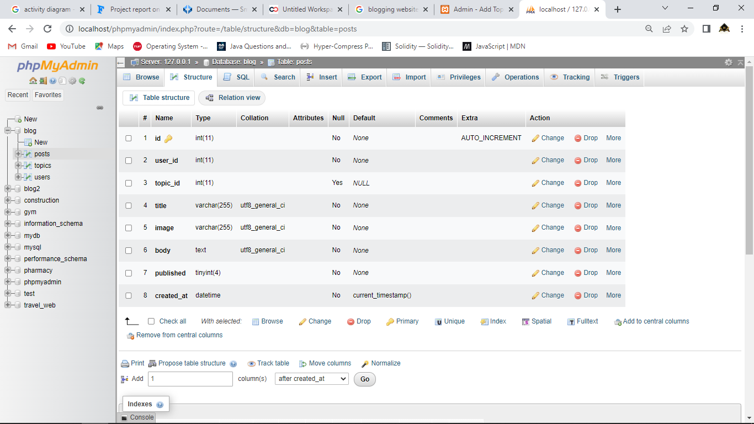

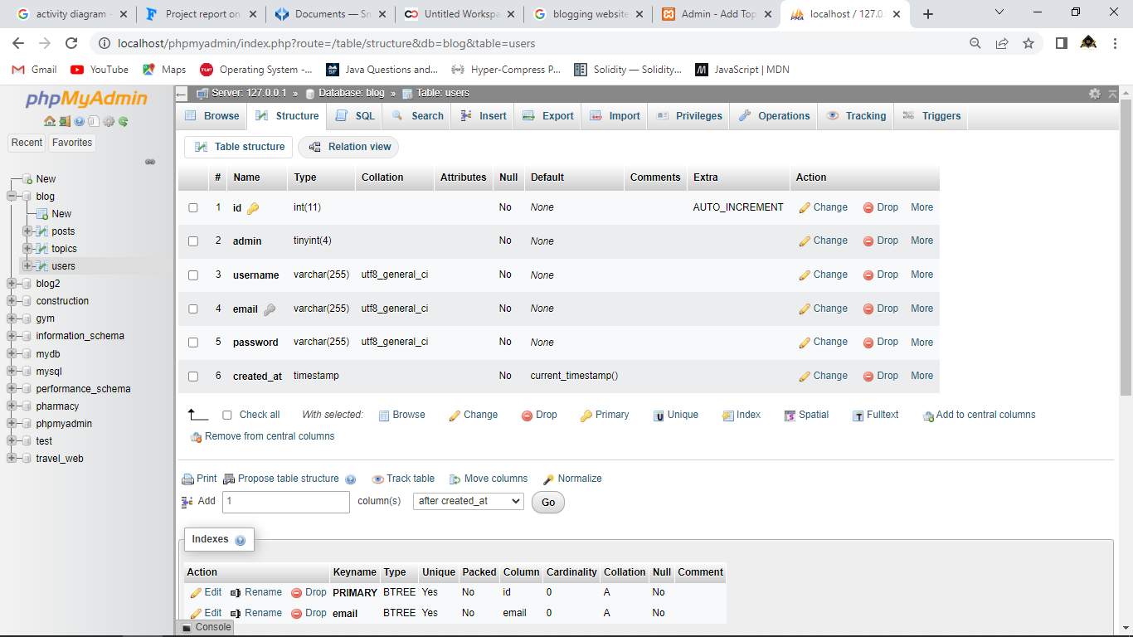

* 1. **Code Snippet**

**Index.php**

<?php

include("path.php");

include(ROOT_PATH . "/app/controlers/topics.php");

$posts = array();

$postsTitle = 'Recent Posts';

if (isset($_GET['t_id']))

{

    $posts = getPostsByTopicId($_GET['t_id']);

    $postsTitle = "You searched for posts under '" . $_GET['name'] . "'";

}

else if (isset($_POST['search-term']))

{

    $postsTitle = "You searched for '" . $_POST['search-term'] . " ' ";

    $posts = searchPosts($_POST['search-term']);

}

else {

    $posts = getPublishedPosts();

}

?>

<!DOCTYPE html>

<html lang="en">

<head>

    <meta charset="UTF-8">

    <meta http-equiv="X-UA-Compatible" content="IE=edge">

    <meta name="viewport" content="width=device-width, initial-scale=1.0">

    <title>Blog</title>

    <!-- Font Awesome -->

    <link rel="stylesheet" href="https://use.fontawesome.com/releases/v5.7.2/css/all.css" integrity=""  crossorigin="anonymous">

    <link rel="stylesheet" href="assets/css/style.css">

    <link rel="stylesheet" href="https://fonts.googleapis.com/css?family=Candal|Lora">

</head>

<body>

    <!-- header  -->

    <?php include(ROOT_PATH . "/app/includes/header.php"); ?>

    <?php include(ROOT_PATH . "/app/includes/messages.php"); ?>

    <!-- Page Slider  -->

    <div class="page-wrapper">

        <!-- Page Wrapper  -->

        <div class="post-slider">

            <h1 class="slider-title">Trending Posts</h1>

            <i class="fas fa-chevron-left prev"></i>

            <i class="fas fa-chevron-right next"></i>

            <div class="post-wrapper">

                <?php foreach ($posts as $post): ?>

                    <div class="post">

                        <img src="<?php echo BASE_URL . '/assets/images/' . $post['image']; ?>" alt="Loading..." class="slider-image">

                        <div class="post-info">

                            <h4><a href="single.php?id=<?php echo $post['id']; ?>"><?php echo $post['title']; ?></a></h4>

                            <i class="far fa-user"> <?php echo $post['username']; ?></i>

                             &emsp;

                            <i class="far fa-calendar"> <?php echo date('F j, Y', strtotime($post['created_at'])); ?></i>

                        </div>

                    </div>

                <?php endforeach; ?>

            </div>

        </div>

    </div>

    <!-- Content  -->

    <div class="content clearfix">

        <!-- main Content  -->

        <div class="main-content">

            <h1 class="recent-post-title"><?php echo $postsTitle; ?></h1>

            <?php foreach ($posts as $post): ?>

                <div class="post clearfix">

                    <img src="<?php echo BASE_URL . '/assets/images/' . $post['image']; ?>" alt="" class="post-image">

                    <div class="post-preview">

                        <h2><a href="single.php?id=<?php echo $post['id']; ?>"><?php echo $post['title']; ?></a></h2>

                        <i class="far fa-user"> <?php echo $post['username']; ?></i>

                         &emsp;

                        <i class="far fa-calendar"> <?php echo date('F j, Y', strtotime($post['created_at'])); ?></i>

                        <p class="preview-text">

                            <?php echo html_entity_decode(substr($post['body'], 0, 150) . '...'); ?>

                        </p>

                        <a href="single.php?id=<?php echo $post['id']; ?>" class="btn read-more">Read More</a>

                    </div>

                </div>

            <?php endforeach; ?>

        </div>

        <div class="sidebar">

            <div class="section search">

                <h2 class="section-title">Search</h2>

                <form action="index.php" method="post">

                    <input type="text" name="search-term" class="text-input" placeholder="Search...">

                </form>

            </div>

            <div class="section topics">

                <h2 class="section-title">Topics</h2>

                <ul>

                    <?php foreach ($topics as $key => $topic): ?>

                        <li><a href="<?php echo BASE_URL . '/index.php?t_id' . $topic['id'] . '&name=' . $topic['name']; ?>"><?php echo $topic['name']; ?></a></li>

                    <?php endforeach; ?>

                </ul>

            </div>

        </div>

    </div>

     <!-- footer  -->

     <?php include(ROOT_PATH . "/app/includes/footer.php"); ?>

    <!-- JQuery  -->

    <script src="https://cdnjs.cloudflare.com/ajax/libs/jquery/3.3.1/jquery.min.js"></script>

    <!-- slider  -->

    <script type="text/javascript" src="https://cdn.jsdelivr.net/npm/slick-carousel@1.8.1/slick/slick.min.js"></script>

    <script src="assets/js/script.js"></script>

</body>

</html>

**Single.php**

<?php include("path.php");

include(ROOT_PATH . "/app/controlers/posts.php");

if (isset($_GET['id']))

{

    $post = selectOne('posts', ['id' => $_GET['id']]);

}

$topics = selectAll('topics');

$posts = selectAll('posts', ['published' => 1]);

?>

<!DOCTYPE html>

<html lang="en">

<head>

    <meta charset="UTF-8">

    <meta http-equiv="X-UA-Compatible" content="IE=edge">

    <meta name="viewport" content="width=device-width, initial-scale=1.0">

    <title><?php echo $post['title']; ?> | BilalWeb</title>

    <!-- Font Awesome -->

    <link rel="stylesheet" href="https://use.fontawesome.com/releases/v5.7.2/css/all.css" integrity=""  crossorigin="anonymous">

    <link rel="stylesheet" href="assets/css/style.css">

    <link rel="stylesheet" href="https://fonts.googleapis.com/css?family=Candal|Lora">

</head>

<body>

    <!-- header  -->

    <?php include(ROOT_PATH . "/app/includes/header.php"); ?>

    <!-- Page Wrapper  -->

    <div class="page-wrapper">

    </div>

    <!-- Content  -->

    <div class="content clearfix">

        <!-- main Content  -->

        <div class="main-content-wrapper">

            <img src="<?php echo BASE_URL . '/assets/images/' . $post['image']; ?>" alt="Loading..." id="singleBlog">

            <div class="main-content single">

                <h1 class="post-title"><?php echo $post['title']; ?></h1>

                <div class="post-content">

                    <?php echo html_entity_decode($post['body']); ?>

                </div>

                <div class="post-content"><br>

                Created At : <i class="far fa-calendar"> <?php echo date('F j, Y', strtotime($post['created_at'])); ?></i>

                </div>

            </div>

        </div>

        <!-- side bar  -->

        <div class="sidebar single">

            <div class="section popular">

                <h2 class="section-title">Popular</h2>

                <?php foreach ($posts as $p): ?>

                    <div class="post clearfix">

                        <img src="<?php echo BASE_URL . '/assets/images/' .$p['image']; ?>" alt="">

                        <a href="#" class="title">

                            <h4><?php echo $p['title']; ?></h4>

                        </a>

                    </div>

                <?php endforeach; ?>

            </div>

            <div class="section topics">

                <h2 class="section-title">Topics</h2>

                <ul>

                    <?php foreach ($topics as $topic): ?>

                        <li><a href="<?php echo BASE_URL . '/index.php?t_id' . $topic['id'] . '&name=' . $topic['name']; ?>"><?php echo $topic['name']; ?></a></li>

                    <?php endforeach; ?>

                </ul>

            </div>

        </div>

    </div>

    <!-- footer  -->

    <?php include(ROOT_PATH . "/app/includes/footer.php"); ?>

    <!-- JQuery  -->

    <script src="https://cdnjs.cloudflare.com/ajax/libs/jquery/3.3.1/jquery.min.js"></script>

    <!-- slider  -->

    <script type="text/javascript" src="https://cdn.jsdelivr.net/npm/slick-carousel@1.8.1/slick/slick.min.js"></script>

    <script src="assets/js/script.js"></script>

</body>

</html>

**Login.php**

<?php include("path.php") ?>

<?php include(ROOT_PATH . "/app/controlers/users.php");

guestsOnly();

?>

<!DOCTYPE html>

<html lang="en">

<head>

    <meta charset="UTF-8">

    <meta http-equiv="X-UA-Compatible" content="IE=edge">

    <meta name="viewport" content="width=device-width, initial-scale=1.0">

    <title>Login</title>

    <!-- Font Awesome -->

    <link rel="stylesheet" href="https://use.fontawesome.com/releases/v5.7.2/css/all.css" integrity=""  crossorigin="anonymous">

    <link rel="stylesheet" href="assets/css/style.css">

    <link rel="stylesheet" href="https://fonts.googleapis.com/css?family=Candal|Lora">

</head>

<body>

    <!-- header  -->

    <?php include(ROOT_PATH . "/app/includes/header.php"); ?>

    <div class="auth-content">

        <form action="login.php" method="post">

            <h2 class="form-title">Login</h2>

            <?php include(ROOT_PATH . "/app/helpers/formErrors.php"); ?>

            <div>

                <label>Username</label>

                <input type="text" name="username" value="<?php echo $username; ?>" class="text-input">

            </div>

            <div>

                <label>Password</label>

                <input type="password" name="password" value="<?php echo $password; ?>" class="text-input">

            </div>

            <button type="submit" name="login-btn" class="btn btn-big">Login</button>

            <p>Or <a href="<?php echo BASE_URL . '/register.php' ?>">Sign Up</a></p>

        </form>

    </div>

    <!-- JQuery  -->

    <script src="https://cdnjs.cloudflare.com/ajax/libs/jquery/3.3.1/jquery.min.js"></script>

    <script src="assets/js/script.js"></script>

</body>

</html>

**Logout.php**

<?php

include("path.php");

session_start();

unset($_SESSION['id']);

unset($_SESSION['username']);

unset($_SESSION['admin']);

unset($_SESSION['message']);

unset($_SESSION['type']);

session_destroy();

header('location: ' .BASE_URL . '/index.php');

**5. DRAWBACKS AND**

**LIMITATION**

**DRAWBACKS AND LIMITATION:**

Blogging has become a popular platform for individuals, businesses, and organizations to share information, express opinions, and connect with their audiences. However, like any other platform, there are certain drawbacks and limitations associated with blogging websites. Some of the major drawbacks and limitations of blogging websites are:

**Lack of control:**

Blogging websites are typically owned and operated by third-party companies, which means that bloggers have limited control over their content and how it is displayed. Changes in the website's policies, algorithms, or ownership can impact how a blog appears and who sees it.

**Limited monetization options:**

While some bloggers may earn money through advertising, sponsored content, or affiliate marketing, many bloggers find it challenging to monetize their content. It can take a significant amount of time and effort to build a large enough audience to generate meaningful revenue.

**Limited design options**:

Blogging websites often provide templates and themes for bloggers to use, but customization options can be limited. This can make it difficult for bloggers to create a unique brand and aesthetic that sets them apart from other bloggers.

**Content restrictions:**

Some blogging websites have content guidelines and restrictions that limit what bloggers can publish. This can be frustrating for bloggers who want to express controversial or unpopular opinions or discuss sensitive topics.

**Limited reach:**

Even with the use of SEO and social media promotion, it can be challenging for bloggers to reach a large audience. The sheer amount of content available on the internet can make it difficult for a blog to stand out.

**Technical difficulties:**

Blogging websites can experience technical difficulties, such as site crashes or slow loading times, which can negatively impact the user experience.

**Content ownership:**

Blogging websites often retain ownership of the content published on their platform. While bloggers may own the rights to their individual posts, the website may have the right to use or repurpose the content as they see fit.

**Dependence on the platform**:

Bloggers who rely solely on a blogging website may be vulnerable to changes in the platform's policies, algorithms, or ownership. If the website shuts down or changes its policies, bloggers may lose their audience and have to start from scratch on a new platform.

**6. PROPOSED EHANCEMENT**

**PROPOSED EHANCEMENT :**

To enhance the blogging experience for users, here are a few potential improvements that could be implemented:

**Customization options**: Blogging websites can provide more customization options for bloggers to create unique designs and layouts. This could include a wider selection of templates, more color and font options, and the ability to add custom code or plugins.

**Improved monetization options**: Blogging websites could provide more options for bloggers to monetize their content, such as pay-per-view or subscription-based models. This would allow bloggers to generate revenue without relying solely on advertising or affiliate marketing.

**Content moderation transparency**: Blogging websites can provide greater transparency around their content moderation policies and decision-making processes. This would help bloggers understand why certain content may be removed or flagged, and would provide them with an opportunity to appeal decisions.

**Enhanced SEO tools**: Blogging websites could provide more robust SEO tools to help bloggers improve their search engine rankings. This could include keyword research and optimization tools, analytics dashboards, and other tools to help bloggers track and improve their traffic.

**Collaboration tools:** Blogging websites can provide tools for bloggers to collaborate with other bloggers or guest writers. This could include the ability to co-author posts, share drafts, and comment on each other's work.

**Content ownership**: Blogging websites can provide greater clarity around content ownership and rights. This could include more transparent terms of service and licensing agreements that clearly outline the ownership and usage rights for the content published on the platform.

**Enhanced technical support**: Blogging websites can provide better technical support for bloggers to resolve issues such as site crashes, slow loading times, and other technical difficulties. This would help ensure a smoother user experience for bloggers and their readers.

**7. CONCLUSION**